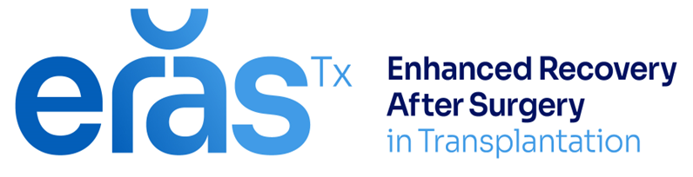
Guidance for staff providing preoperative
counselling to living kidney donors.

Explain the main principles of Enhanced Recovery after Surgery (ERAS)
A programme designed to help living kidney donors to recover more quickly following surgery and improve their overall experience.

We expect this programme will;
    - Reduce the risk of complications after surgery
    - Help the donor to recover more quickly
    - Help to make better use of resources, reducing overall costs to NHS
    - Provide a better understanding of what to expect during their hospital stay
    - Give them the opportunity for more involvement in their care
    - improve their overall experience as they recover

Explain target day of discharge but manage patient expectations-
      - reassure them regarding not reaching all targets
      - all donors are different, and some may need to stay in longer
      - We will not discharge them until the donor and the team feel they are ready.

Key components

- Fitness in preparation for living kidney donation – keeping well and optimising fitness for donation
  - Include
  - Importance of maintaining/improving fitness levels before donation
  - Positive changes (even if only small) can help improve the body’s ability to cope with the donor operation. A longer walk, quicker pace, extra flight of stairs etc.
  - Signpost to local resources as applicable.
    - Smoking cessation
    - Nutritional advice and weight loss management services if available
    - KidneyBeam: http://www.kidneybeam.com/

- Food and fluids – The way we manage fluids during the operation and in the first few days afterwards.
- Include –
- Discontinuation of IV fluid administration at conclusion of surgery
- Normal oral intake as desired from the immediate post-operative period
- Consideration of regular laxative until normal bowel motion

- Pain – The way we manage pain to provide good relief and to minimise side effects from the drugs.
- Explain effectiveness of regular paracetamol as a base- `pain ladder’
- Explain less opiates = less side effects (nausea, fatigue, constipation)
- Reassure there are other pain medications available including non-pharmaceutical methods such as good positioning, holding a rolled –up towel and heat packs)
- Stress the importance of informing nurses if in pain and not being ‘brave’
- Aiming for functional analgesia (can they cough, deep breathe, move)

- Mobility – mobility programme to help recovery as well as reduce the likelihood of complications of infections or blood clots.
- Explain the importance of mobilising early
- manage expectations – when to ‘dig deep’ and when to rest
- encourage them to take charge of their own mobility targets and ask for assistance where needed, to achieve them.

- Urinary catheter – Aiming to remove as soon as safe to do so (usually on the day of surgery)
    - Explain that it helps to reduce the likelihood of urine infections.
    - Makes mobilising easier and is more comfortable
    - Explain their role in being proactive and prompting the donation team about this
    - Explain there is sometimes the need for the catheter to stay longer and this will be explained to them if so.

- Shared care plan (omit if not using)
- Explain care plan is there to support them through their stay in hospital
- Provides information about what to expect each day
- Ask them to engage with their care and fill in information, recording their progress.

- Discharge education – Explain that the nurses will provide them with education about how to care for themselves before they leave hospital.
    - Explain target day/time
    - Support person can be available to listen if donor wishes (liaise with nurses for timings)
    - Encourage patient to talk to the team about any discharge plans/concerns as early as possible
- Onward home-
  - Explain how follow up works - Where to go with concerns, who to contact
- Explain the importance of good nutrition and being active/safely rebuilding strength after surgery. (mention e-link or printed advice if appropriate)

