Return this form to your local Customer Service Manager or email NHSBTCustomerService@nhsbt.nhs.uk

The majority of potential pack defects or leaking components can be reported by sending a photograph and this completed form to NHSBT, before discarding the unit(s) at the hospital.
If you are unable to discard the component(s) at your hospital, please discuss this with your local Hospital Services Department. Please complete sections A and C and return this form with the component(s).
For all other complaints, please complete sections A and B only.

Section A: Customer Details
Hospital Name: | Account No. (Pulse/ODS/NCI):
Your Name: | Contact number/email:
Incident Date: Click or tap to enter a date. | Today’s Date: Click or tap to enter a date.

Section B: Complaint Details
Please include relevant reference numbers (e.g. donation / request / sample number) and state any impact on patient (e.g. delayed transfusion, patient re-bled etc.)

Section C: Damaged/Returned Component(s)
Provide details of the component including component type and donation number(s).
Photos can be attached in this section by clicking the ‘picture’ box below.
The damaged area(s) can be indicated on the pack images below by using the ‘Draw’ tab in the above ribbon and circling the area.

Click on the icon to attach photo:


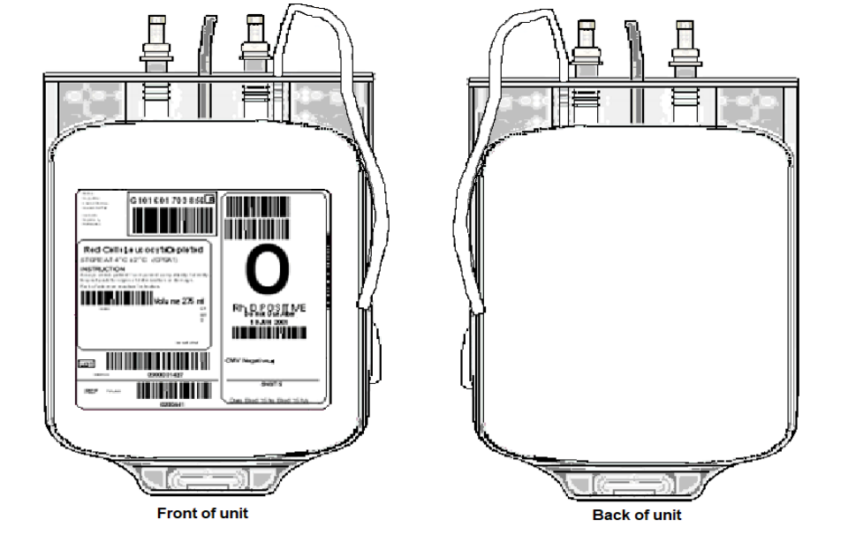

Section D: NHSBT QA only
Please include relevant information for logging on Q-Pulse (such as Pack defect Number, Lot Number etc.)

