Keeping moving and rebuilding strength

after your Liver Transplant

The information below provides advice and education to help your recovery and rehabilitation after your liver transplant. Rebuilding your strength and fitness will help you to get back to doing the things you want to do more quickly and live an ongoing healthy life with your new liver. Here you will find both exercises and some tips on how to improve your general levels of physical activity and eat well to help your body to recover and build strength.

Safety Advice
If you feel unwell with any of the following, take a rest day and do not return to exercise until you feel better:
- a bad cold, flu, a high temperature, feeling very tired or generally unwell
- any injury to a muscle or joint
- acute episode of arthritis in ankles knees or hips.

Stop immediately if while exercising you experience any of these:
- chest pain
- dizziness
- extreme shortness of breath.

If you experience chest pains or extreme shortness of breath that does not go away when you stop exercising, please call an ambulance.

Avoid abdominal exercises or heavy lifting for 6-8 weeks post-surgery. This should include lifting anything heavier than the weight of a full kettle to minimise excessive discomfort and pain.

Advice and Activity Once You Return Home
You may have already been walking and exercising in hospital, or you may still need a walking stick or help with your day-to-day tasks. Whatever level you start from, it is important that you try to increase your activity levels daily.

This advice covers suggestions for exercise and activity for:

- Weeks 1-6 after your liver transplant
- Weeks 6-12 after your liver transplant
- Weeks 12+ after your liver transplant

Weeks 1-6
It is important to keep your level of physical activity and movement to make the most of the health benefits this brings.
including:
- An increase in bone density (stronger bones)
- An increase in muscle strength, mass and function (better strength and fitness)
- An increase in flexibility
- Supporting your mental health

Following a progressive walking programme will help with your overall health, slowly improving your strength and stamina. Start with short 5-10- minute walks twice daily and gradually increase the time spent walking each week. Providing you are medically well, you should be able to walk for around 30-45 minutes daily at week 6. An example of how you might increase your walking is detailed below.

Setting daily activity targets helps to reduce the amount of time you are not moving (sedentary behaviour). This may include breaking up the time you spend sitting by standing and moving for 1 minute, every hour.

Example: Progressive Two-Week Walking Programme
Week 1 | Day 1 | Day 2 | Day 3 | Day 4 | Day 5 | Day 6 | Day 7
Walking Time | 12 min | 12 min | 15 min | 12 min | 12 min | 15 min | 12 min
Week 2 | Day 1 | Day 2 | Day 3 | Day 4 | Day 5 | Day 6 | Day 7
Walking Time | 15 min | 15 min | 17 min | 15 min | 15 min | 17 min | 15 min

Weeks 6-12
- A slow increase in how fast you walk will help improve your strength, stamina and flexibility. Try to increase your walking speed so you are breathless but can talk and have a conversation.
- Walking on different surfaces can help to improve your walking tolerance. (For example, a steady hill or on uneven ground).
- Setting realistic goals such as walking to the next outdoor landmark will help with your overall fitness progression.

You may wish to slowly add extra daily activity from 6 weeks after your transplant. This may include daily activities around the house such as ironing and cooking.

It is important you take regular breaks and split your activity up throughout the day. This will help minimise tiredness and discomfort.

Weeks 12+
Providing you feel well in yourself, you may wish to progress to more strenuous tasks including moderate/vigorous activity.

You may begin a combination of upper and lower body strengthening exercises two to three times a week. It is important to leave 1-2 days between completing your strengthening exercises to allow your body to rest and recover.

Each session, work through all the exercises twice. They should feel difficult, but not impossible.

As the exercises become easier, you can do one of the following
- Add more repetitions per exercise
- take less rest between exercises
- increase the overall number of sets per session.
You should only change one of these at a time.
If you wish to return to a specific sporting activity, please discuss this with your GP.

Strengthening & Resistance Exercises

Start with Level 1 and as the exercises become easier, you can progress to Level 2.

Safety Tip: Only complete the exercises on the floor, if you can safely get yourself on and off the floor.

Exercise 1: Sit to Stand Squats

Level 1 - Stand up and sit down slowly from a chair. If able, try not to use
your arms.

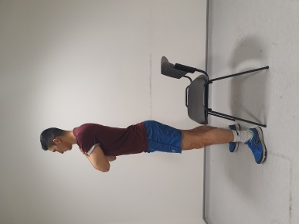
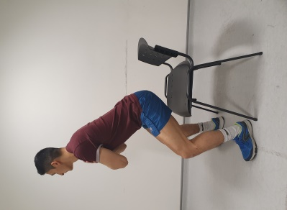
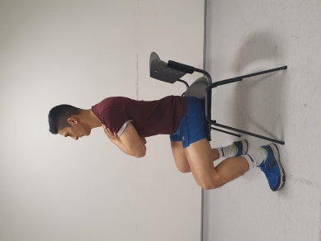

Level 2 - Keeping your back straight. Bend your knees and move your bottom back. Then return to standing slowly.
Reach your hands out and stick your bottom back. Go down as far as you can, just above 90 degrees and return to standing. Ideally, sit back into your heels and then come back up.

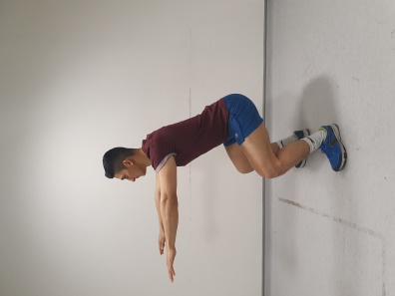
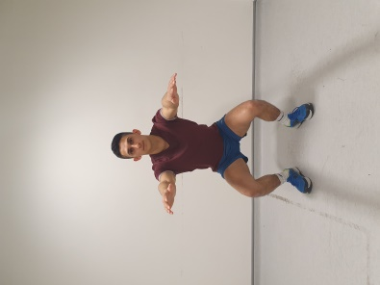
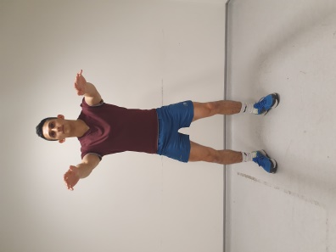

Exercise 2: Static and dynamic Lunges
Level 1 - Start standing with your feet together, and step forwards letting your back knee drop towards the floor. Ensure that your front knee does not go beyond your toes and keep your back straight. You can hold onto a rail.

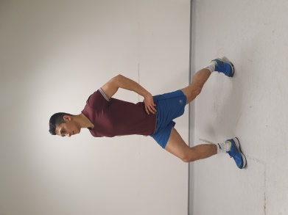
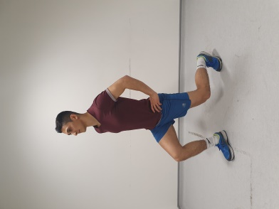
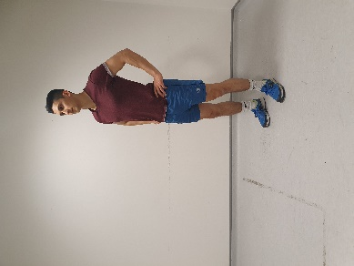

Level 2 – Start standing with your feet together, holding a light weight in each hand. Step forwards letting your back knee drop towards the floor, then step back to neutral with your feet together. Keep alternating stepping forward with each leg.

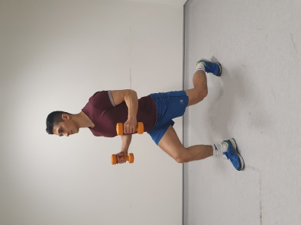

Exercise 3: Step Ups

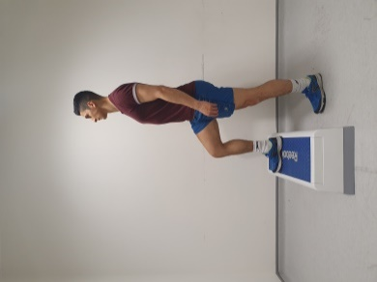
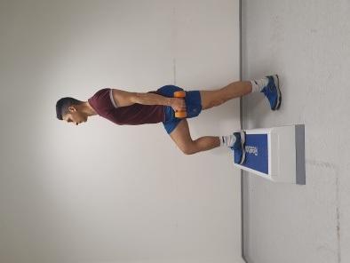
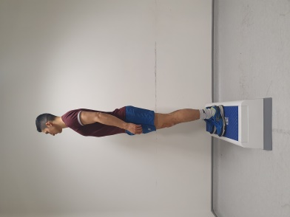

Level 1 - Step both feet onto the step and then step both feet back down. If you need, you can lightly hold a handrail for balance. Try to alternate which foot you step up with first

Level 2 - As above but holding weights in your hands to make it harder or step onto the 2nd step.

Exercise 4: Double Leg Calf Raises à Single Leg

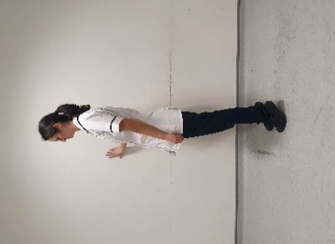
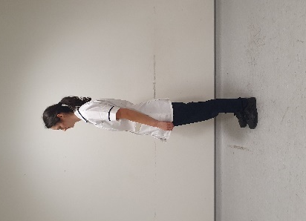
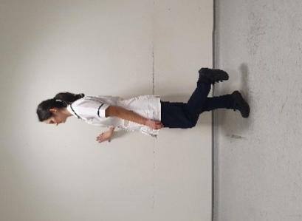

Level 1 - Hold onto a solid surface and go up onto your tip toes in a controlled manner. Slowly lower yourself down.

Level 2 - Hold onto a solid surface and put all your weight only onto ONE leg. In the same way, go up onto your tip toes on the one foot, and slowly come down. Repeat on the other leg too.

Exercise 5: Bicep Curls
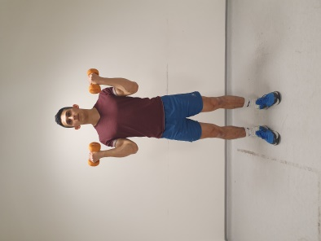
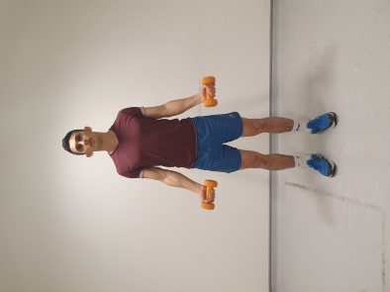

Hold two light weights in your hands and bend your elbows (bicep curl) and then relax and straighten the elbows down.

Exercise 6: Overhead Shoulder Press

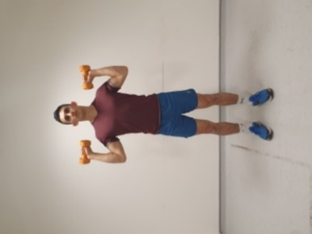
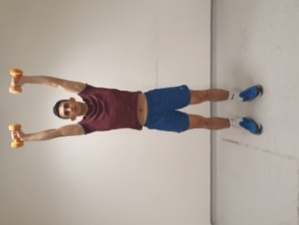

Push the weights above your head, bring back down and return to original position.

Exercise 7: Bridging – Only do this exercise after 8 weeks post op

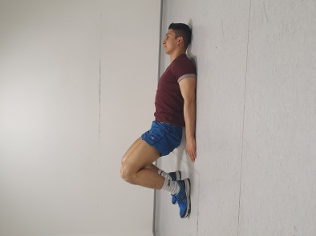
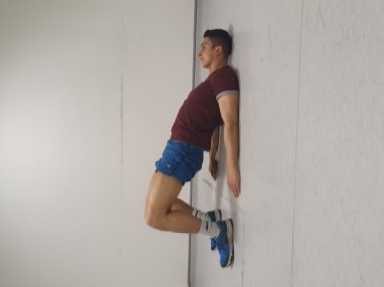

Lie on your back keeping your neck rested, in bed or on the floor. Bend your knees so your heels are grounded. Engage your abdomen muscles and push your lower back into the ground / bed. Squeeze your buttocks and lift / clear off the ground, hold for a few seconds.
Slowly come back down and relax.
Keep Improving

As you get stronger and find the exercises are easier it is important to increase the number of repetitions and sets so that you keep improving.

Repetitions = How many you do in a row e.g. 10 squats

Sets = How many rounds of repetitions you do e.g. 10 squats, 20 seconds rest and another 10 squats, would be classified as “2 sets”

Start doing Level 1 exercises at 8-12 reps x1-3 sets
1st Progression: Level 1 exercises: 8-12 reps 3-5 sets
2nd Progression: Level 2/3 exercises: 8-12 reps x1-3 sets
3rd Progression: Level 2/3 exercises: 8-12 reps 3-5 sets

- At first you may find you only have energy to complete one or two exercises at a time. This is ok and will still help you recover. You can spread exercises out throughout the day.
- As you start to get stronger, you will find you can complete more at one time.
- When you feel you could do two more reps at the end of your set try moving to the next level
- If you don’t have weights at home, you can hold bottles of water or cans of food.

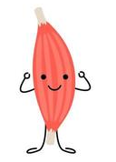

What to Eat and Drink as part of my recovery

First 3 to 6 months - high energy and protein diet
Following your transplant, nutrition is important for the recovery process. A high energy and high protein diet will help with wound healing, help your body fight any infection, build muscle, and help regain any weight lost pre-transplant and immediately post-transplant. As you recover post-transplant, your appetite and food intake should gradually return to normal. This can take time due to nausea, feeling full, poor appetite or post-transplant complications. If you were under-weight prior to surgery, a high energy and protein diet may be necessary for a longer period until your weight is healthy.
Tips for a high energy and protein diet include: -
- Eat little and often – try to include a small snack between meals and before you go to bed.
- Snack ideas include cheese and biscuits, nuts, scone, tea cake, yoghurt, biscuits, olives, cake, sausage roll, slice of pizza, cereal, mini dessert, spring roll, or hummus and dip.
- Try to avoid filling yourself up with large servings of fruit, vegetables, salads, or soups as they do not provide much energy.
- Go for full-fat versions of foods and avoid light or diet products.
- Consider enriching your foods, for example add extra cheese, cream, butter or margarine, honey, milk powder or crème fraiche to your foods. Add grated cheese or cream to soup, cream or cheese to mashed potato, extra mayonnaise to sandwiches or butter or a white sauce to vegetables
- Try to include a source of protein with each meal, (e.g., chicken, fish, red meat, pulses, beans, Quorn, eggs, cheese, soya, tofu) and try to incorporate protein into your snacks, e.g., cheese and biscuits or nuts.
- Focus on nutritious and nourishing drinks. These include full fat or semi skimmed milk, malted drinks, such as Horlicks or Ovaltine made with milk, smoothies, fruit juice, and full sugar fizzy drinks. Avoid sugary drinks if you have diabetes. Milk is a good source of energy and protein.
- Try to have pudding after your main course or as an in-between meal snack, e.g., sponge and custard, cheesecake, ice cream and fruit, trifle, or rice pudding.
- Convenience foods or ready meals can be a useful stand-by and can be equally nourishing.

If you have diabetes, check with your dietitian as some of the above suggestions may not be suitable.

You may be given nutritional supplements before or after your transplant. Your dietitian will speak with you to see if this is still needed when you go home. If you are losing weight without meaning to, speak with your dietitian, ask your consultant, or transplant coordinator to refer you.

Healthy eating and lifestyle -long term (Around 6 months onwards)
Once you have recovered from the operation, your wounds have healed, and you are not losing weight without meaning to, the high energy and high protein diet can be relaxed. For your long-term health it is important to eat a healthy balanced diet and lead an active lifestyle. This is to reduce the risk of health conditions such as diabetes, high blood pressure, cancer, cardiovascular disease, and osteoporosis. Due to the immunosuppressant medications, your body is more vulnerable to these conditions. Excess weight gain is common post-transplant and increases the risk of the conditions listed above. Steroids can also add to this as they can increase your appetite and desire to eat more.

Tips for a healthy balanced diet
The Eatwell Guide below shows the amounts of each food group you should try to eat in one day.
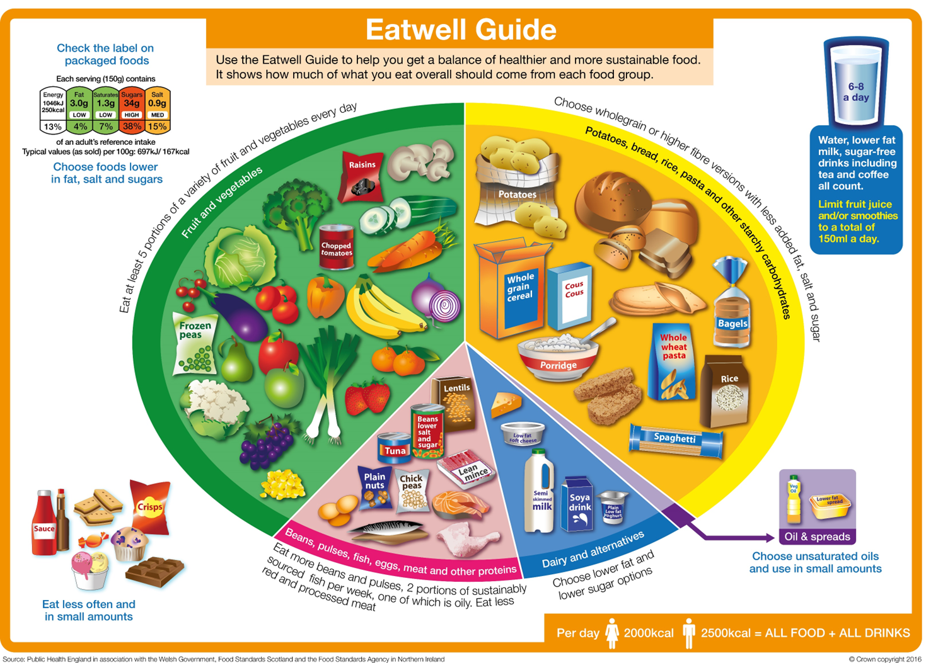

The Eatwell Guide is divided into five food groups.
- Potatoes, bread, rice, pasta and other starchy carbohydrates – include one of these foods with every meal. Avoid frying these foods or adding lots of butter/oil to these foods. Try to choose wholegrain or wholemeal varieties as this will increase the fibre in your diet.
- Fruit and vegetables – aim for 5 portions a day. These can be fresh, frozen, or tinned. Try to include a variety of colours. Fruit and vegetables are a good source of vitamins, minerals, and fibre.
- Beans, pulses, fish, eggs, meat and other proteins – These foods all contain protein which is important for healing and rebuilding muscle after your transplant. Try to have a source of protein with every meal.
- Dairy and alternatives, such as milk, yoghurt, eggs and cheese - are good source of calcium and important for strong bones, aim to consume two to three portions each day, e.g. 200mls glass of milk, a yoghurt or 30g of cheese. Choose lower fat options, such as semi skimmed milk, reduced fat cheese and low-fat yoghurts. Ensure soya/oat/rice milks are ‘fortified with calcium’.
- Oils and Spreads – Unsaturated oils and spreads such as olive oil, vegetable oil and soft spreads made from unsaturated oils. Use these products sparingly if you are trying to avoid gaining weight.
- Foods to eat less often and in smaller amounts: These foods are not essential in your diet and often contribute to weight gain. Examples are cakes, biscuits, chocolate, sweets, puddings, pastries, ice cream, jam, honey, crisps, sauces, butter, cream, mayonnaise, takeaways and ‘fast food’ such as McDonald’s, KFC etc

Reduce your salt intake.
For your health it is recommended you follow a no added salt diet. This is to reduce the risk of high blood pressure and heart disease. No more than 6g salt a day is recommended. This is equivalent to approximately 1 teaspoon. About 70% of our salt intake comes from processed or everyday foods which has salt already added to it, these include products such as bread, crisps, breakfast cereals and ready meals.
The following foods are high in salt, try to reduce your intake of these or have smaller amounts:-
- Bacon, ham, sausages, salami
- Cheese
- Smoked meats and fish
- Olives
- Salted crisps and nuts
- Stock cubes, gravy, ketchup, soy sauce

Tips to reduce your salt intake:-
- Avoid salt in cooking or at the table
- Use herbs, spices, pepper, lemon for seasoning instead of salt
- Gradually reduce your salt intake as your taste buds will adapt
- Choose unsalted crisps, nuts, popcorn
- Reduce intake of processed foods.

It can be helpful to look at food labels as most packaging has traffic light coding so you can see the salt content at a glance. Try to avoid foods that are coloured red for salt, which indicates the food is high in salt. Choose foods with green or amber coding instead.
How much salt is too much per 100g?
 | Low | Medium | High
Salt (per 100g) | 0-0.3g | 0.3-1.5g | More than 1.5g

Bone Health - Calcium and Vitamin D
It is important to have enough vitamin D and calcium in your diet to keep your bones strong. Taking steroids long term can weaken your bones and increase the risk of fractures. Getting enough calcium and vitamin D can help to prevent this.
Good sources of calcium include milk, cheese, yoghurts, sardines or pilchards with bones and calcium-enriched soya products.
Vitamin D helps the absorption of calcium from foods. Most vitamin D is made in the body via sunlight. However, because of the anti-rejection medications, your body is less able to protect itself from the damaging effects of the sun on your skin and so it is advised to protect yourself from the sun. Good sources of vitamin D from the diet include oily fish (mackerel, sardines), eggs, margarines and fortified breakfast cereals. Unfortunately, you cannot get enough vitamin D from food alone and you may need to take a supplement, especially as your sun exposure is likely to be reduced.

