Improving your fitness and Nutrition before your Liver Transplant
Here is some advice and education about how you can help yourself to prepare for a Liver Transplant. You will find an explanation of some simple exercises, as well as general advice on how to be more active and improve your nutrition.

Waiting for your Transplant
You may have a short or long wait for your liver transplant, and we know that there can be a range of emotions you can feel in this time. The good news is that you can do something to help yourself. During this time many patients find that their physical fitness, muscle size and strength get worse. This can put you at higher risk of complications after surgery. Research shows that patients who are more active and well-nourished (from eating the right kinds of food) have better and often quicker recovery from surgery. Keeping your heart and lungs active can help your body to cope better with the stress of surgery on your body. So, whilst you are waiting, try to include the following advice into you’re your daily routine.

Safety Advice
Exercising is safe when you have liver disease, but it is important to listen to your body and be sensible about how you slowly build up your exercise tolerance, especially if you have never done exercise or have not done any for some time.
Please read the following safety advice before you start any physical activity. If you have any worries about exercising, please talk to your transplant team or GP. If you feel unsteady, unsafe or have been experiencing recent falls please make sure someone is with you when you are doing any physical activity.

It is normal to get out of breath when you push yourself with activities, but you must STOP exercise if you get any sudden symptoms including:
- Chest pain or tightness
- Feeling dizzy, nauseous, clammy or cold
- Feeling increasingly wheezy
- Develop pain
If you have chest pain or extreme shortness of breath that does not go away when you stop exercising, please call an ambulance.

Daily Lifestyle
- You can improve your fitness by making simple changes like walking instead of using a bus or car or taking the stairs instead of a lift. Continue with your normal daily activities and minimise the time that you are inactive.

- You may find it helpful to keep a step count diary to monitor your progress and help motivate you. You usually have a step counter on your smartphone, or you may have a watch that counts your steps. If not, you can order a cheap pedometer online.

Whatever level of activity you are starting from just aim to increase your own step count each week. Some is good, more is better – it all counts!

Week commencing (date) | Weekly steps | Goal for next week

Cardiovascular Exercise
Cardiovascular exercise is any activity that increases your heart rate and breathing rate. It can include activities such as walking, jogging, cycling, swimming, gardening, dancing, or using a rowing machine.
General guidelines recommend 150 minutes of moderate intensity cardiovascular exercise each week to improve your heart and lung function. Moderate intensity is when you are breathing faster but you are still able to hold a conversation.
The chart below is a guide to help you find the right level for you.
Research looking at patients waiting for a liver transplant, suggests that even short bursts (less than 5 mins) of moderate intensity physical activity can help keep you stronger. Something is always better than nothing, therefore starting small and building up can really help you improve your function and overall wellbeing.
Always think of safety when choosing what type of exercise to do. If you have trouble with your balance, it may be safer to use a stationary bicycle or do seated exercises. If you have pain in your joints, you may prefer a low impact form of exercise such as swimming.
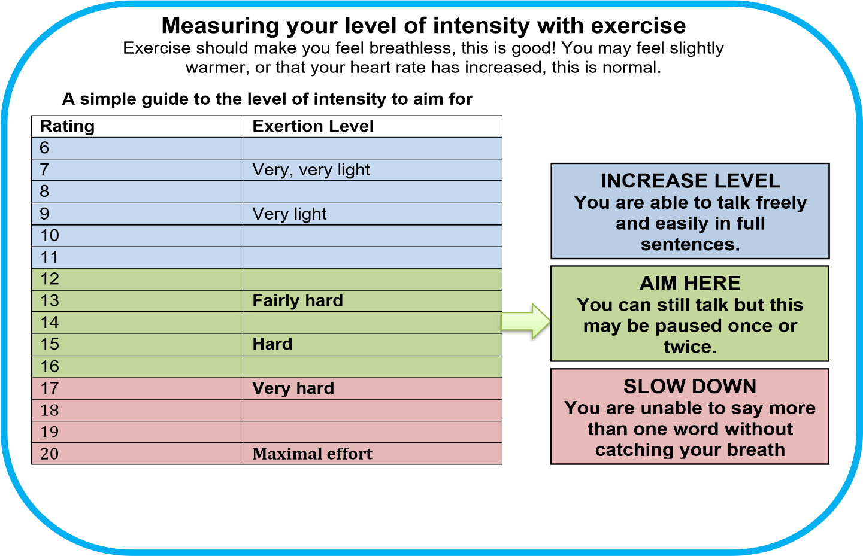
Strengthening & Resistance Exercises
If you have liver cirrhosis, you are at high risk of losing muscle as the liver can’t store energy well and instead starts to use your muscle as an energy source.

You will have information about how to help combat that, but it is also important that you do 2-3 sessions of strength training exercises per week to maintain and improve muscle strength. If you start to lose muscle strength you will notice it may become harder to do the day-to-day tasks you would normally be able to do and can start to affect your quality of life and how easily you can socialise with people or do your usual hobbies. Below is a programme you can follow to help with this.

Start with Level 1 and as the exercises become easier, you can try Level 2.
(Safety Tip: Only complete the exercises on the floor, if you can safely get yourself on and off the floor
Exercise 1: Sit to stand and squats
Level 1 - Stand up and sit down slowly from a chair. If able, try not to use your arms.
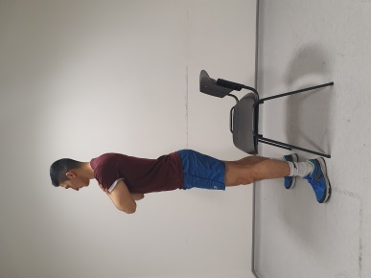
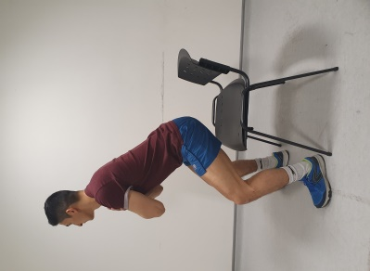
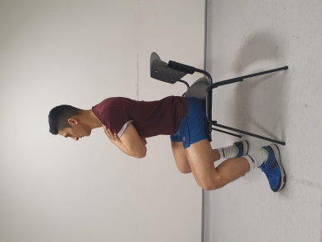

Level 2 - Keeping your back straight. Bend your knees and move your bottom back. Then return to standing slowly.
Reach your hands out and stick your bottom back. Go down as far as you can, just above 90 degrees and return to standing. Ideally, sit back into your heels and then come back up.
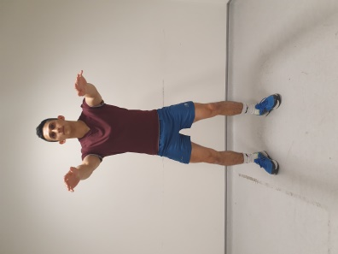
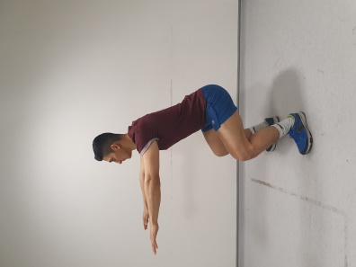
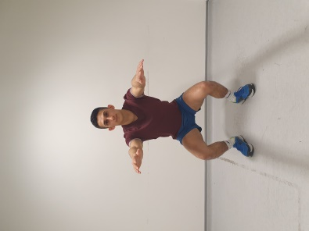

Exercise 2: Static Lunges and dynamic Lunges
Level 1 - Start standing with your feet together, and step forwards letting your back knee drop towards the floor. Ensure that your front knee does not go beyond your toes and keep your back straight. You can hold onto a rail.
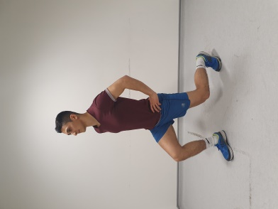
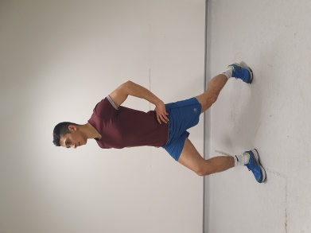
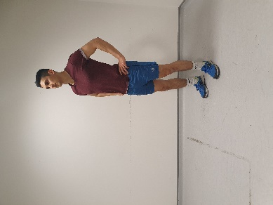

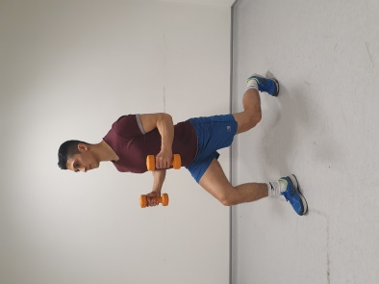
Level 2 – Start standing with your feet together, holding a light weight in each hand. Step forwards letting your back knee drop towards the floor, then step back to neutral with your feet together. Keep alternating stepping forward with each leg.

Exercise 3: Step Ups
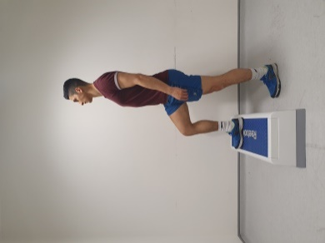
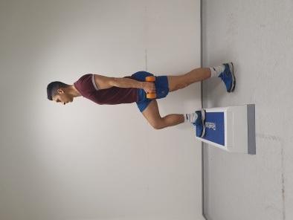
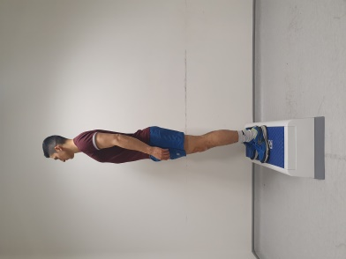

Level 1 - Step both feet onto the step and then step both feet back down. If you need, you can lightly hold a handrail for balance. Try to alternate which foot you step up with first
Level 2 - As above but holding weights in your hands to make it harder or step onto the 2nd step.

Exercise 4: Hand to Knee
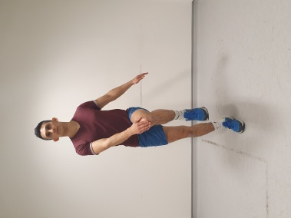
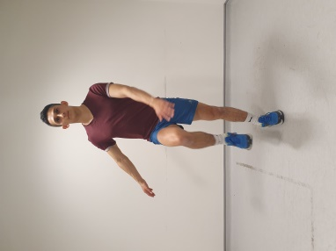
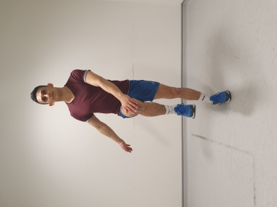

Level 1 - Bend your knee towards your chest and touch your hand to your opposite knee, then repeat on the other side.
Level 2 - Repeat as above but jump into each position

Exercise 5: Double leg calf raises and single leg
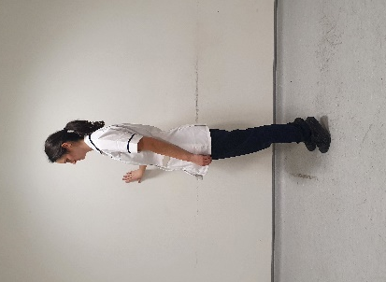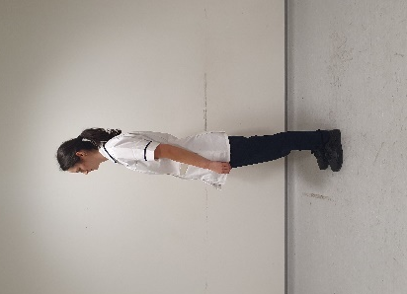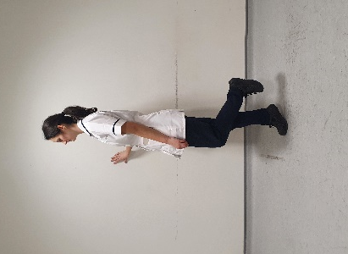

Level 1 - Hold onto a solid surface and go up onto your tip toes in a controlled manner. Slowly lower yourself down.
Level 2 - Hold onto a solid surface and put all your weight only onto ONE leg. In the same way, go up onto your tip toes on the one foot, and slowly come down. Repeat on the other leg too.

Exercise 6: Wall press and press ups
Level 1 - Place your hands on a sturdy wall, keeping your hips and body straight slowly bend and then straighten your elbows.
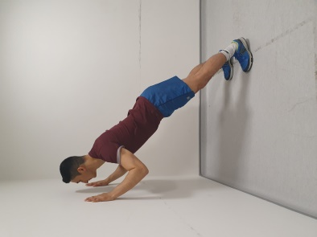
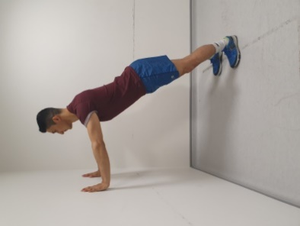

Level 2(a) - Position yourself with your knees on the floor and your arms straight. Keeping your hips and body straight slowly bend and then straighten your elbows.
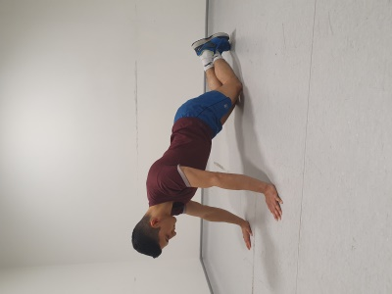
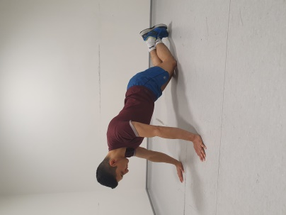
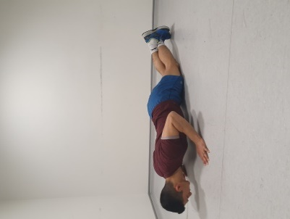

Level 2(b) - Position yourself lying on your stomach with your hands by your chest. Push up so your elbows are straight, and your hips and body are straight and then slowly lower back to the floor.

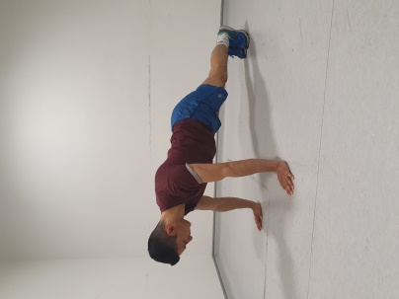
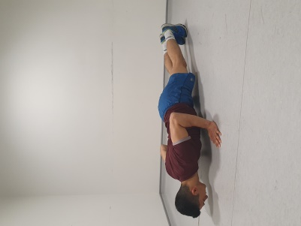

Exercise 7: Bicep Curls
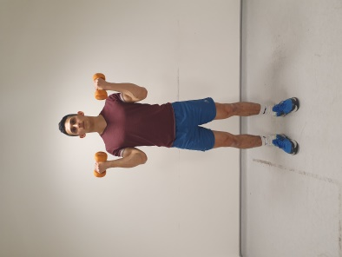
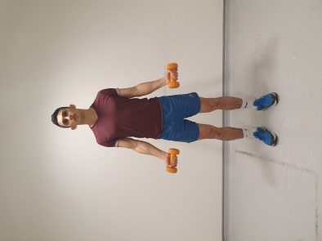

Hold two light weights in your hands and bend your elbows (bicep curl) and then relax and straighten the elbows down.
Exercise 8: Overhead Shoulder Press
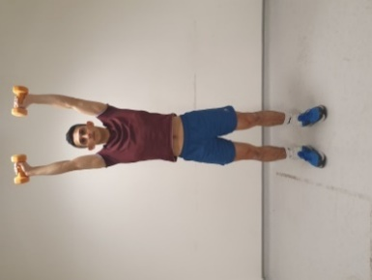
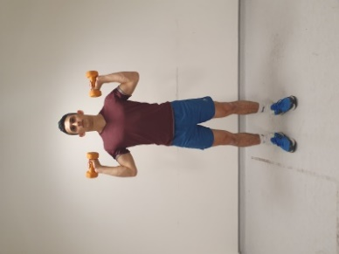

Push the weights above your head and then bring back down and return to original position.
Exercise 9: Core Stability
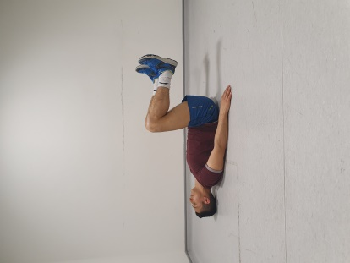
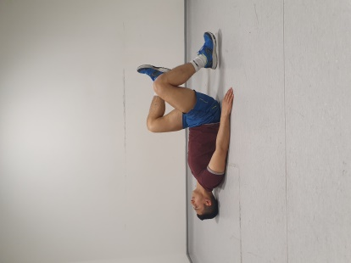
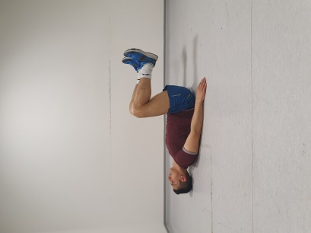

Lie on your back keeping your neck rested, in bed or on the floor. Lift your knees to create a 90-degree angle, so they are parallel to the floor.

Tap one foot at a time down, and bring back to neutral, engaging your lower back with the ground to keep yourself steady.

Exercise 10: Bridging

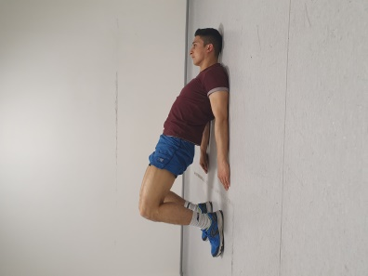
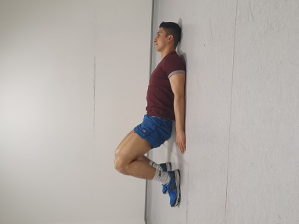

Lie on your back keeping your neck rested, in bed or on the floor. Bend your knees so your heels are grounded.

Engage your abdominal muscles and push your lower back into the ground / bed. Squeeze your buttocks and lift / clear off the ground, hold for a few seconds. Come back down and relax.

Keep Improving
As you get stronger and find the exercises are easier it is important to increase the number of repetitions and sets so that you keep improving.
Repetitions = How many you do in a row e.g. 10 squats
Sets = How many rounds of repetitions you do e.g. 10 squats, 20 seconds rest and another 10 squats, would be classified as “2 sets”
Start doing Level 1 exercises at 8-12 reps x1-3 sets
1st Progression: Level 1 exercises: 8-12 reps 3-5 sets
2nd Progression: Level 2/3 exercises: 8-12 reps x1-3 sets
3rd Progression: Level 2/3 exercises: 8-12 reps 3-5 sets
When you feel you could do two more reps at the end of your set try moving to the next level.
At first you may find you only have energy to complete one or two exercises at a time, that’s fine you can spread them out throughout the day. As you start to get stronger you will find you can complete more of them at one time.
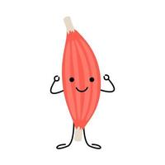
If you don’t have weights at home, you can hold bottles of water or cans of food.

Symptom management and exercise tips
Sometimes the symptoms from your liver disease can make it harder to get started exercising or you may even struggle just to get up and about to do your normal daily tasks.
Fatigue is a feeling of tiredness more than normal which doesn’t go away with resting or sleep. Here are some top tips for managing this to help you keep moving and make progress.
- Stay active, gentle paced exercise can improve fatigue symptoms, be sure to stop and rest when needed.

- Break tasks into smaller steps with time for rest

- Consider sitting to do tasks.

- Build rest into your daily routine - don’t wait until you are fatigued before resting.

- Get into positions that will help with energy conservation. E.g. relax the shoulders, keep elbows low and close to the body.

- Learn how to relax and practice this regularly as part of your daily routine.

- Plan ahead, stay organised and pace yourself so you don’t take on too much or get bored.

- Ask for help with tasks where possible.

- Adopt good sleep hygiene. Wind down before bedtime, make sure your bedroom is a relaxing, dark and cool space and importantly a screen free zone!

- Try to sleep and wake at the same time – routines can help to restore a good sleeping pattern.
Nutrition and Liver Cirrhosis
It is important to eat a balanced diet when you are living with advanced liver disease (cirrhosis). People living with liver cirrhosis are at risk of malnutrition (weight loss and muscle wasting). Your liver is where you normally store energy from food. Once you have cirrhosis, your liver cannot store the energy from food for as long, and you are at higher risk of muscle loss. Your body is also using more energy and protein, so you may lose weight without trying to. You may also experience symptoms that make it hard to eat, such as nausea, loss of appetite, and feeling full quickly. This can be worse if you have ascites (fluid around your middle).
Signs of malnutrition to look out for include weight loss and feeling weak. If you have ascites or oedema (fluid on your ankles) then this may mask weight loss, so look for signs like loose clothing and jewellery, bones becoming more visible or your arms looking thinner.
If you are aiming to increase exercise to prevent muscle loss or re-build strength, it is very important that you are also eating enough food to build muscle mass.
If you have liver cirrhosis, try to follow this dietary advice:
  EVERY 2-3 HOURS | Eat every 2-3 hours through the day, including a source of carbohydrate such as bread, pasta, rice, potatoes, cereal or crackers.  This means having 3 meals daily, as well as snacks between your meals and at bedtime. This is because your liver cannot store the energy from food for as long as it used to due to the cirrhosis, and if you have long gaps without carbohydrate your body will start to break down muscle for fuel.
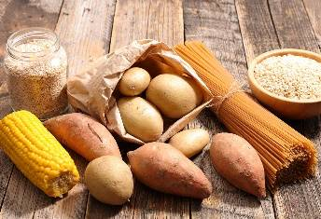  CARBOHYDRATE  SNACK | Eat a bedtime snack containing 50g carbohydrate to provide your body with the energy it needs overnight.  Examples of a suitable snack would be:  - A bowl of cereal and a banana  - 2 slices of toast and a glass of milk  - Cheese and 3-4 crackers.
  PROTEINS | Eat a high protein diet. Protein is found in meat, fish, chicken, eggs, milk, dairy products such as cheese and yogurts, as well as vegetarian/vegan sources like lentils, beans, tofu and seitan. This is essential to build and repair muscles. Try to include oily fish at least once a week.  People living with liver cirrhosis need more protein than normal. Eating extra protein can prevent muscle wasting and is important for rebuilding lost muscle.
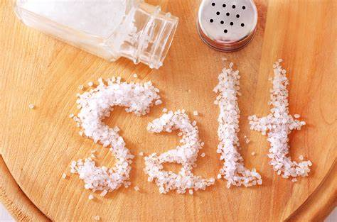  SALT | If you have a build-up of fluid around your middle or in your legs (ascites/oedema), avoid adding salt to your food, and avoid high salt foods such as oxo drinks, Bovril, pot noodles, cup-a-soups, tinned soups and crisps. This is because a high salt diet can make your body retain extra fluid when you have liver cirrhosis.  Try using other flavourings instead, like black pepper, herbs, spices, lemon juice and vinegar.

  ADD  CALORIES | If you have lost weight or have a poor appetite, try to increase your intake of high calorie foods. Try adding butter, nut butter, cheese or cream into your favourite foods, have extra puddings, snack on unsalted nuts and drink full fat milk to increase your nutritional intake.  Consider asking your GP or liver consultant for a referral to a dietitian. Consider a daily A-Z multivitamin if you feel you are not eating well. See the “Food Fortification” Video in the table overleaf for more tips.
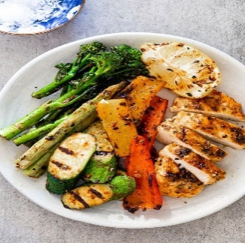  HEALTHY SWAPS | If you have been advised to lose weight, limit high fat/sugar foods such as biscuits, cakes, sweets, crisps, pies and pastries. Swap these snacks for healthy alternatives like fruit or vegetable sticks and hummus.  Grill, steam or air fry food instead of frying it and cut off any visible fat on meat.
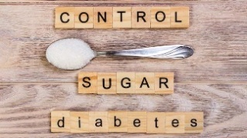  CONTROL DIABETES | If you have diabetes, it is important you try to keep your blood sugars well controlled.  Choose diet versions of fizzy drinks, swap to sweetener in tea/coffee, and speak to your diabetes team if your blood sugars are raised.
  NUTRITIONAL SUPPLEMENTS | If you are seeing a dietitian and have been prescribed supplement drinks, aim to take these as prescribed.  They taste best when chilled, so keep them in the fridge or serve with ice. If you dislike these or cannot take the quantity prescribed, contact your dietitian as there may be different ones available.
Useful resources - places you can find more information or help

Active 10- walking programme
https://www.nhs.uk/live-well/exercise/walking-for-health/

Couch to 5K
https://www.nhs.uk/live-well/exercise/get-running-with-couch-to-5k/

British Liver Trust:
https://britishlivertrust.org.uk/information-and-support/living-with-a-liver-condition/diet-and-liver-disease/physical-activity-exercise/#:~:text=Moderate%20aerobic%20activity%20(cardio),-Moderate%20activity%20is&text=Aim%20to%20do%20150%20minutes,for%20too%20long%20at%20first.

GP Exercise Referrals:
You can ask the GP or your CNS/ Physio to refer you to your local ‘Exercise on Referral’ service if this is available in your local area. This will give you access to a supportive programme to induct you into your local gym and provide you with tailored support
Local Groups:
Look out for exercise and walking groups in your local area

Useful resources- places you can find more information or help

British Liver Trust – Cirrhosis and Diet  https://britishlivertrust.org.uk/information-and-support/living-with-a-liver-condition/diet-and-liver-disease/cirrhosis-and-diet/ | 
British Liver Trust – Coping with Eating Difficulties  https://britishlivertrust.org.uk/information-and-support/living-with-a-liver-condition/diet-and-liver-disease/coping-with-eating-difficulties/ | 
British Liver Trust – Diet and Liver Disease (PDF Leaflet)  https://17xpvwx1p0y4h.cdn.shift8web.com/wp-content/uploads/Diet-and-Liver-Disease_web_JUN21_b.pdf | 
British Dietetic Association (BDA) Food Facts - Food labelling: Nutrition Information  https://www.bda.uk.com/resource/food-labelling-nutrition-information.html | 
BDA Food Facts – Salt  https://www.bda.uk.com/resource/salt.html | 
BDA Food Facts – Spotting and Treating Malnutrition  https://www.bda.uk.com/resource/malnutrition.html | 
British Liver Trust – Fatty Liver Disease and Diabetes  https://britishlivertrust.org.uk/information-and-support/liver-conditions/non-alcohol-related-fatty-liver-disease/fatty-liver-disease-and-diabetes/ | 
NHS Lothian – Food Fortification  https://vimeo.com/720164990/27db1224ea | 

