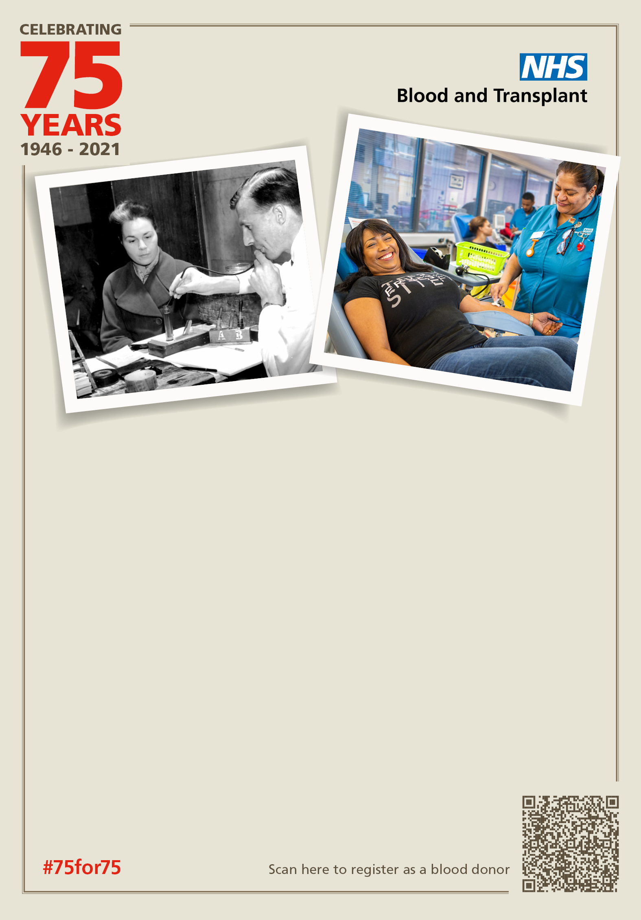­­­

**NHS Blood and Transplant is celebrating:**

**75 years giving the gift of life**

We are asking organisations to help us celebrate giving the gift of life for 75 years. We need 75 of your employees to register and donate blood.

Register your organisation now to support your NHS at [business.enquiries@nhsbt.nhs.uk](mailto:business.enquiries@nhsbt.nhs.uk)

Look out for our LinkedIn campaign and show your support using #75for75 #backtotheoffice #healthandwellbeing #giveblood

