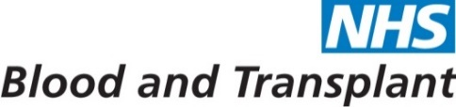
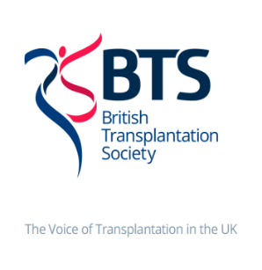
July 2020 • Issue 10

UK LKD Network Newsletter

INTRODUCTION

Dear Colleagues

We hope that this Newsletter - the first since December 2019 - welcomes you back ‘post COVID’ to your roles in living donation. We have aimed to include information on a ‘need to know’ basis whilst you restore your programmes back to some normality.
Restoration of LDKT across the UK
This is the most urgent challenge - critical for patients and for the whole programme. Many of you will have seen the recent email about Restoration Plans and options for consideration, sent to Clinical Directors in kidney transplant centres and copied to the Network. If not, the documents can be found here:
Covering letter: https://nhsbtdbe.blob.core.windows.net/umbraco-assets-corp/19081/covering-letter-restarting-and-expansion-of-living-donor-kidney-transplantation-final.pdf
Options paper: https://nhsbtdbe.blob.core.windows.net/umbraco-assets-corp/19140/13-july-2020-approved-recommendations-for-restarting-ldkt.pdf

Survey of Living Donors
With the support of kidney charities, a survey of previous, present and potential living donors was recently performed by NHSBT via social media to understand the willingness of people to consider living donation in the COVID era. Key findings from 240 responses:
- Keen to see programmes re-start
- High level of confidence in clinical teams and the NHS
- Majority of donors willing, if required, to:
  - Move to another centre for surgery
  - Be looked after by another clinical team
  - Undergo remote/virtual assessment where appropriate
- Testing of donors, recipient and staff for COVID-19 and PPE were considered critical
- Outcome for recipient due to COVID-19 influenced willingness to donate more than donor-related considerations for a greater proportion of donors
Access the full survey report at: https://nhsbtdbe.blob.core.windows.net/umbraco-assets-corp/19170/living-donor-survey-june-july-2020.pdf

BAME people were under-represented in this sample. Feedback from patient representatives suggests that there may be increased concern about the impact of COVID-19 and living donation for people from BAME backgrounds.

UK Living Kidney Sharing Scheme
The UKLKSS was suspended for April and July due to COVID. Approximately 80 patients identified in an exchange in February have yet to be transplanted. We hope that the Restoration Plan initiative (above) will help to address this. A decision about whether the October matching run is feasible will be made soon, largely dependent on how many exchanges can be achieved by 30th September. The latest KAG update and performance data can be found here:
https://nhsbtdbe.blob.core.windows.net/umbraco-assets-corp/19240/june-2020-kag-uklkss-update-paper-final-for-newsletter.pdf

COVID-19 Resources
Throughout the pandemic, NHSBT, the BTS and RA have provided ‘free access’ information for clinicians, transplant patients and commissioners and issued regular bulletins to keep everyone updated. Latest resources and guidance relevant to clinical practice in the COVID era can be accessed at the following links:
NHSBT: https://www.odt.nhs.uk/deceased-donation/covid-19-advice-for-clinicians/
Latest LDKT donor-recipient factsheets:https://www.organdonation.nhs.uk/become-a-living-donor/ (Kidney concertina)
BTS: https://bts.org.uk/information-resources/covid-19-information/
RA: https://renal.org/covid-19/

Other Network Resources
Click on the link below for a list of up to date resources and how to access them:
https://nhsbtdbe.blob.core.windows.net/umbraco-assets-corp/19241/ldkt-useful-resources-v5-may-2019.pdf

Dates for the diary- to be advised

UK LKD Network Meeting
We are currently looking at options for a UK LKD Network Meeting in Early Spring 2021. Watch this space.

Certificates of attendance for the February 2020 Network meeting will be sent separately to all attendees.
Access all presentations here: https://www.odt.nhs.uk/living-donation/uk-living-kidney-donation-network/

Thank you for everything that you continue to do to restore business as usual and hope that you all get a break at some point over the summer.

Please contact us if we can help or support you in anyway.

Lisa Burnapp- Clinical Lead Living Donation
Caroline Wroe- Chair of the UK LKD Network
Katie Vinen- Renal Association Representative

