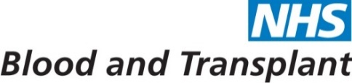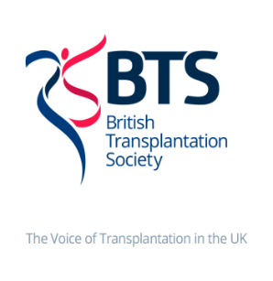

**December 2018 • Issue 5**

**UK LKD Network Newsletter**

**INTRODUCTION**

Dear Colleagues

Welcome to the December 2018 LKD network newsletter, we are looking forward to welcoming you to the first network study day in Birmingham on January 24th 2019. The meeting has proved very popular and we are grateful to everyone for accommodating changes to ensure that as many units as possible are represented. Latest statistics for 2018/19 show that there have been 648 living kidney donors in the UK since April.

**Update on Cr51 EDTA supply:**

Thank you for responding to the recent email asking for information about the method your department use to assess GFR in donors. 50% of units are using Cr51 EDTA, 42% are using Tc 99m-DTPA and 8% are using Iohexol. The majority of units using Cr51 EDTA plan to move to Tc 99m-DTPA when the supply of Cr51 EDTA runs out.

Demand on Tc 99m-DTPA is likely to rise significantly and potentially outstrip availability. In addition, if there is a no deal to Brexit the supply of all radioisotopes into the UK is under significant additional threat. We have therefore set up a working group representing the Renal Association, British Transplant Society, NHS Blood and Transplant and the UK LKD network to address this issue and have highlighted our concern to the Department of Health and Social Care. The working group is also reviewing guidance around the use of Iohexol and will create an addendum to the BTS/RA UK Guidelines for Living Donor Kidney Transplantation for the assessment of mGFR. This will be sent round the network and added to the UK LKD Network area on the ODT Clinical website from early 2019 along with an update on isotope availability.

Please liaise with your local Nuclear Medicine department over this change. It remains possible to still assess both split function, isotope GFR and CT renogram on the same day but the timing will depend upon the isotope of choice and local factors.

Guidance for nuclear medicine teams can be found at:

<https://www.bnms.org.uk/images/BNMS_GFR_guidelines_in_BNMS_template_format_FINAL.pdf>

For newsletters, information about the network and resources for living kidney donation please visit <https://www.odt.nhs.uk/living-donation/uk-living-kidney-donation-network/>

Lastly, we wish you a very warm Christmas and Happy New Year

Yours sincerely



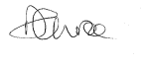

Prof Caroline Wroe Dr Katie Vinen

Chair of the UK Living Kidney Donation Network RA Lead for Living Kidney Donation

Consultant Nephrologist Consultant Nephrologist,

South Tees NHS Foundation Trust Kings College Hospital