Help us go Pink for Organ Donation Week

Currently three people die every day in need of an organ transplant, often because families haven’t discussed the subject and don’t know whether to consent to donation on behalf of their relative or not.

Starting on the 3rd September Organ Donation Week will see individuals and organisations across the United Kingdom working to raise awareness of the important need for families to talk about organ donation to help save lives.

A key part of the campaign is encouraging conversations in communities and NHSBT teams across the nation are working with organisations to light up buildings, monuments and other tourist attractions pink for some or all of the week.

Going pink could be easier than you think.

- Colour changing LED lighting

Many buildings and structures now feature these low energy light fittings which feature colour changing luminaries for both interior and façade illumination. They allow simple programme alterations via fitted control panels to allow organisations to mark special days, celebrating local, national and international events.

- Façade Lighting

Standard exterior façade lighting can be easily adapted by using a colour film that can be fitted over existing luminaries. More commonly known as Theatre or Lighting Gel this flexible polycarbonate or polyester material (similar to acetate) that can easily be cut to size for a wide range of applications.

- Projector lighting

Using projector lighting you can illuminate any building that does not have the above options. These lighting projectors can be installed on balconies or a set distance from the building. A specialist lighting company can provide details on the best options available to you. If you plan to install the projector in a public space, you may need to seek advice from your local authority.

In addition, some projectors would have the capability to project a specific image such as the ‘Yes I donate’ graphic or the NHS Organ Donor Card.

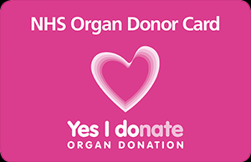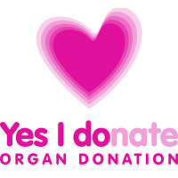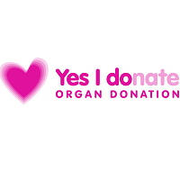

We really hope that you can get behind this vital campaign and help us light up the skyline during Organ Donation Week.

Organ Donation colour specifications:

Pantone Rhodamine Red
RGB: 224/17/157
HTML: E0119D

Social Media: You could also post on social media using the following suggestions:

It’s Organ Donation week and we’ve lit up ….. to encourage people to talk to their family about organ donation. Words save lives. @NHSOrganDonor #YesIDonate

We’re supporting Organ Donation Week and we’ve lit up ….. to encourage people to talk to their family about organ donation and join the NHS Organ Donor Register @NHSOrganDonor #YesIDonate.

Belfast City Hall – Organ Donation Week 2017
